IN THE COURT OF SH. ANUJ KUMAR SINGH LD. CJM, PATIALA HOUSE COURTS, NEW DELHI
Misc. Application No.______ of 2025
In
FIR No. 538/2024
IN THE MATTER OF:
State ….. Prosecution
Versus
Unknown Persons ….Accused
In Re:
Abdul Qadir Raja ….Applicant
Versus
State ….. Prosecution
FIR No. 538/2024 dated 27.11.2024 registered for offence U/s 318,319,61(2) BNS,2023.
PS.: Special Cell, IFSO.
INDEX
S. No | Particulars | Page No.
 | Application by and on behalf of Abdul Qadir Raja sole proprietor of M/s Raja Wool House U/s 503 BNSS or any other appropriate sections of the Sanhita for de-freezing of the current bank account no. 9146265472 with Kotak Mahindra Bank in the interest of justice.
Annexure-1
Copy of the Paytm transaction done by Mr. Irshad Ali in the current bank account no. 9146265472 with Kotak Mahindra Bank of the Applicant for purchase of goods sold to Mr. Irshad Ali during usual course of business.
 | Vakaltnama

Place: New Delhi Applicant
Dated: (Through Counsel)
Through

TUSHAR GUPTA
Advocate for the Applicant
Ph. 88601 04097
Ch. No-297, Patiala House Court,
New Delhi-110001
.

IN THE COURT OF SH. ANUJ KUMAR SINGH LD. CMM, PATIALA HOUSE COURTS, NEW DELHI
Misc. Application No.______ of 2025
In
FIR No. 538/2024
IN THE MATTER OF:
State ….. Prosecution
Versus
Unknown Persons ….Accused
In Re:
M/s Raja Wool House ….Applicant
Versus
State ….. Prosecution
FIR No. 538/2024 dated 27.11.2024 registered for offence U/s 318,319,61(2) BNS,2023.
PS.: Special Cell, IFSO.
APPLICATION BY AND ON BEHALF OF ABDUL QADIR RAJA SOLE PROPRIETOR OF M/S RAJA WOOL HOUSE U/S 503 BNSS OR ANY OTHER APPROPRIATE SECTIONS OF THE SANHITA FOR DE-FREEZING OF THE CURRENT BANK ACCOUNT NO. 9146265472 WITH KOTAK MAHINDRA BANK IN THE INTEREST OF JUSTICE.
Most Respectfully Showeth:
- That the present application is being preferred by the applicant Mr. Abdul Qadir Raja who is the sole proprietor of M/s Raja Wool House, seeking de-freezing of the current bank account of M/s Raja Wool House bearing no. 9146265472 with Kotak Mahindra Bank which had been marked debit freeze by the investigating agency in pursuance of the complaint filed by one Mr. Arun Kuamr Jain with the Cyber Cell, IFSO and National Cyber Crime Reporting Portal.
- That Mr. Abdul Qadir Raja through his proprietorship concern M/s Raja Wool house, having address at 25, New Market, T.T Nagar, Bhopal (GST No. 23AAGFR8819J1ZV) has been running a business for the past 40 years at the above-mentioned address. The Applicant is involved in trading of clothing items and on day-to-day basis the Applicant receives several payments from customers who come to purchase several clothing items available at premises of the Applicant.
- That in addition to cash payments, the applicant also receives payments through the paytm app linked with the current bank account of the Applicant bearing no. 9146265472 with Kotak Mahindra Bank, which has been marked debit freeze in the present case.
- That on 05.11.2017 payment of Rs. 1200 was made by one Mr. Irshad Ali through the Paytm app, having transaction ID No. 20241105111110000060653283947209359 and and again on 21.11.2024, payment of Rs 1140 was again made by Mr. Irshad Ali through the Paytm app, having transaction ID No. 20241121110970000066422171117147159.
Copy of the Paytm transaction done by Mr. Irshad Ali at the premises of the Applicant is annexed herewith and marked as Annexure-1.
- It is respectfully submitted that the said payments were received by the Applicant during normal and usual course of business, for bona fide business purposes as the Applicant had sold certain good to Mr. Irshad Ali. The Applicant is not known to Mr. Irshad Ali and the relation shared between the Applicant and him is purely of a seller and customer.
- That to the shock and surprise of the Applicant, an email was received by the Applicant that the current bank account of the Applicant has been marked debit freeze in compliance of legal notice dated 27.01.2025. the relevant portion of the email has been reproduced below for the convenience of the Hon’ble Court.
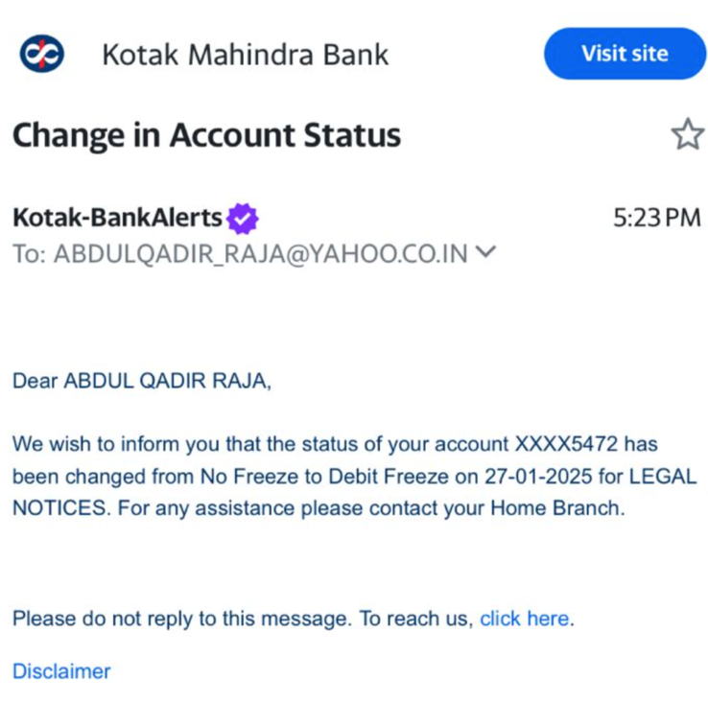
- That upon inquiry it come to the knowledge of the Applicant that a complaint had been filed by one Mr. Arun Kumar Jain with Special Cell, IFSO regarding of cheating of Rs. 18.86 Cr by unknown persons in New Delhi and it has been alleged that out of the total sum, the above mentioned two transactions by one Mr. Irshad Ali form part of the alleged money trail through which the cheated amount had transferred from the complainant.
- That the said transaction forms the 5th layer of the money trail from the complainant who has been allegedly cheated by the accused persons.
- It is respectfully submitted that the Applicant is in no manner concerned with the present case and has been unnecessarily roped in the present case as firstly the Applicant had no knowledge of the alleged offence and secondly the said payment was received in the usual course of business for bona fide business transaction.
- That for the above mentioned two transaction the entire bank account of the Applicant has been marked debit freeze which is causing grave prejudice and hardship to the Applicant as the Applicant is not able to conduct his business and earn his livelihood as the day-to-day transaction of the Applicant have been stopped.
- Further, the Applicant is also not able to meet outside liabilities/ payments to third parties as banking services with the said current bank account of the Applicant have been suspended due to the debit freeze marked against the said bank account.
- That the net result of the said action is that Applicant is not able to receive payments, not able to makes payments to vendors and several cheques issued by the Applicant to the other third parties prior to marking of the debit freeze are not being honored due the debit freeze marked against the said bank account, despite their being sufficient balance to honor the same. The Applicant is under a risk of incurring criminal liability under the Negotiables Instrument Act due to the debit freeze marked against the current bank account of the Applicant.
- That the Hon’ble Delhi High Court vide its order dated 16.07.2021 in matter titled “Vijay Kumar Sharma and Anr. Vs Directorate of Enforcement W.P.(C) 6236/2021” had passed the following directions:
3. In the light of this submission of the petitioner, Mr. Mahajan, learned counsel for the respondent was granted time to obtain instructions. Today, he submits that as only the amounts as on date available in these bank accounts have been attached and therefore, the respondents have no objection if the concerned banks are directed to permit the petitioners to operate these bank accounts subject to securing the amount available in these accounts as on date.

4. In view of the aforesaid stand taken by the respondents, the three banks namely- Kotak Mahindra Bank, Nobel Cooperative Bank and Punjab National Bank details whereof are noted hereinbelow are directed to permit the petitioners to operate these bank accounts subject to the available amount available in these accounts as on date being placed in FDRs in the name of the petitioners, which FDRs will not be released to the petitioners unless any orders to the contrary are passed by any competent Court or by the Appellate Tribunal….

5. Needless to state, once the aforesaid amount is secured by way of an FDR, the banks will permit the petitioners to operate these accounts, in the normal course of business.
(Emphasis Supplied)
- That the Applicant undertakes to abide by all the conditions imposed by the Hon’ble Court.
- That the present application has been filed in the most bonafide manner and in the interest of justice.
PRAYER
It is therefore most respectfully prayed that the Hon’ble Court may be pleased to:
- Pass necessary order and directions thereby directing de-freezing of the current bank account of the Applicant bearing no. 9146265472 with Kotak Mahindra Bank in the interest of justice.
AND
- Pass any other appropriate orders and directions as the Hon’ble Court deems it fit and proper in light of the facts and circumstances of the case.
It is prayed accordingly.
Place: New Delhi Applicant
Dated: (Through Counsel)
Through

TUSHAR GUPTA
Advocate for the Applicant
Ph. 88601 04097
Ch. No-297, Patiala House Court,
New Delhi-110001

